Excel Assignment 2 – Data Exploration
Moved the dataset to Power query for data cleaning by clicking on Data From Table/Range option
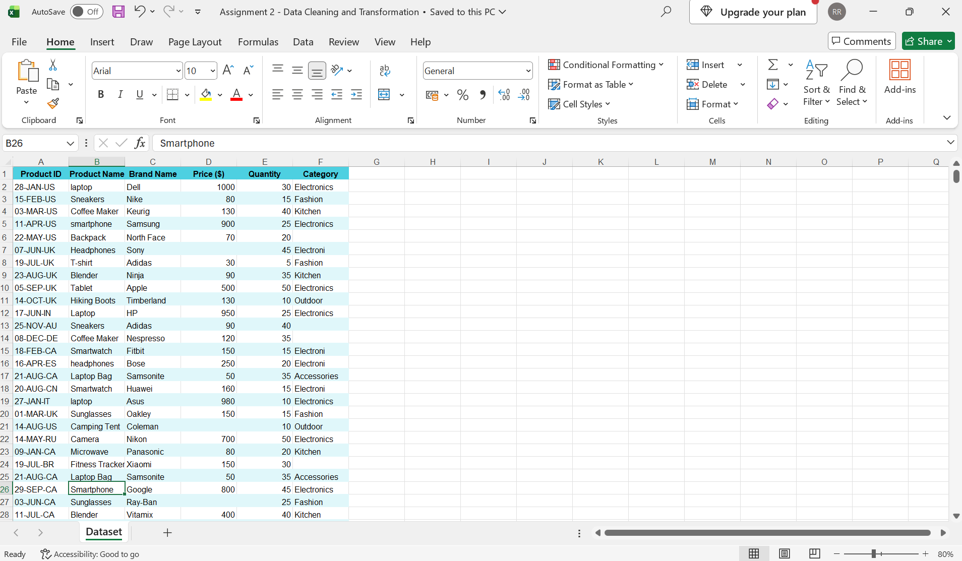

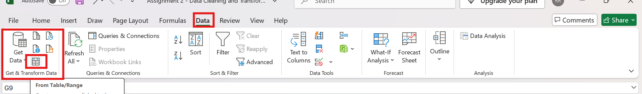

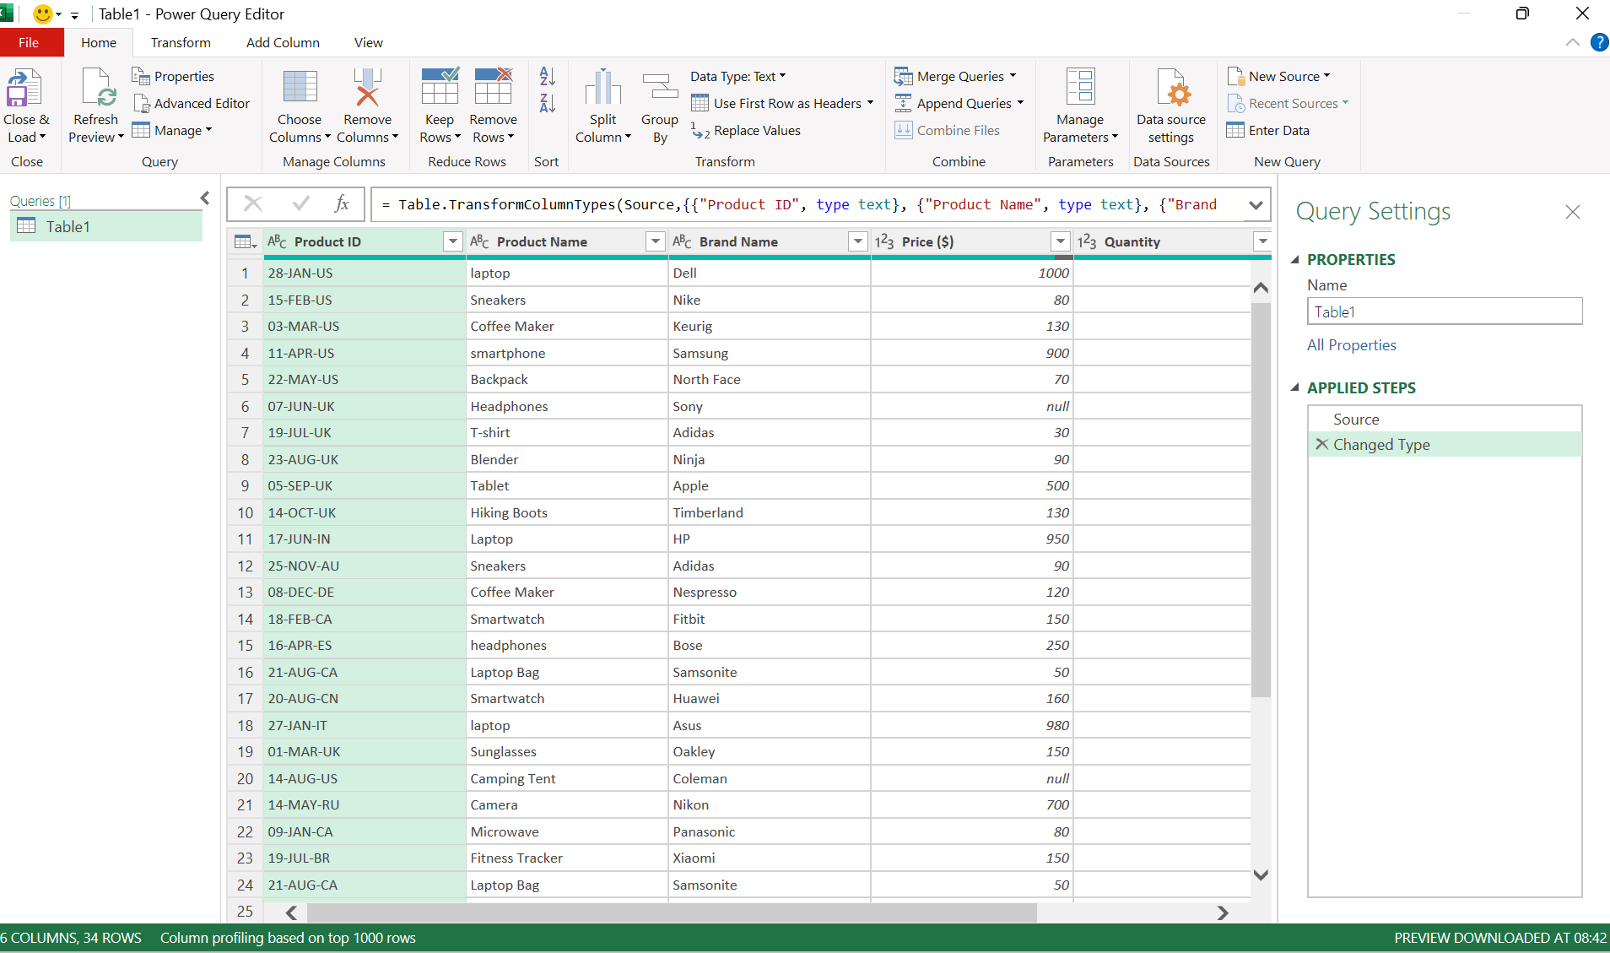

- Handling Missing Values:
Found null data in the price column – since we have outlier, I chose Mediam to fill the missing data,
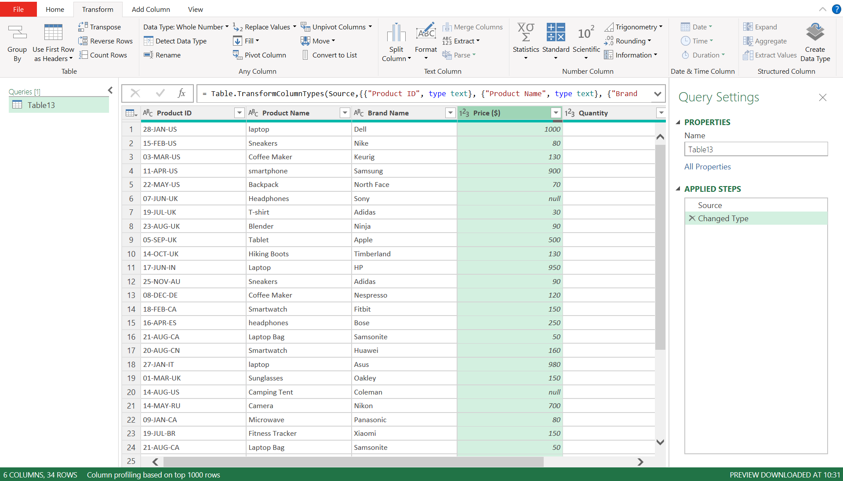
Selected the Price column – under Transform tab – selected statistics - Median to find the Median
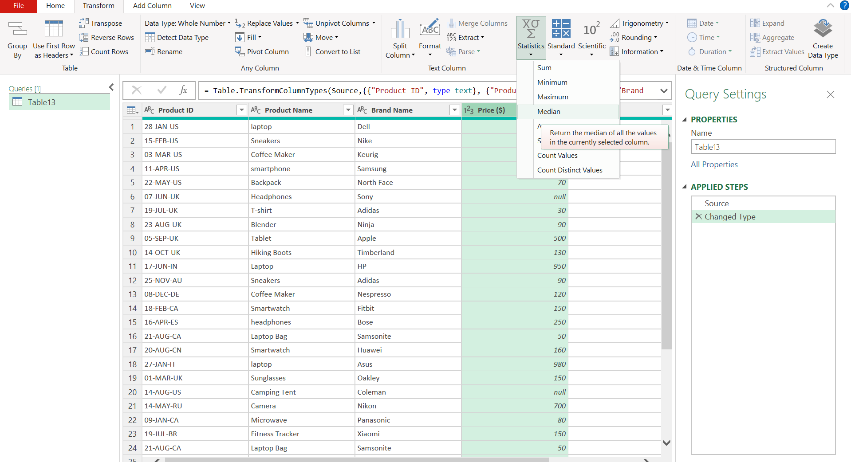

Power Query returned a Median value for the price column – “130”
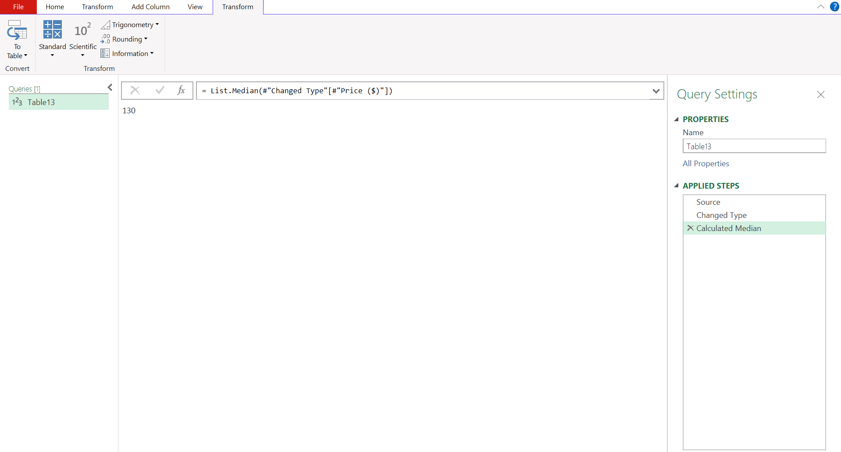

Replaced the null value with 130 in the price column
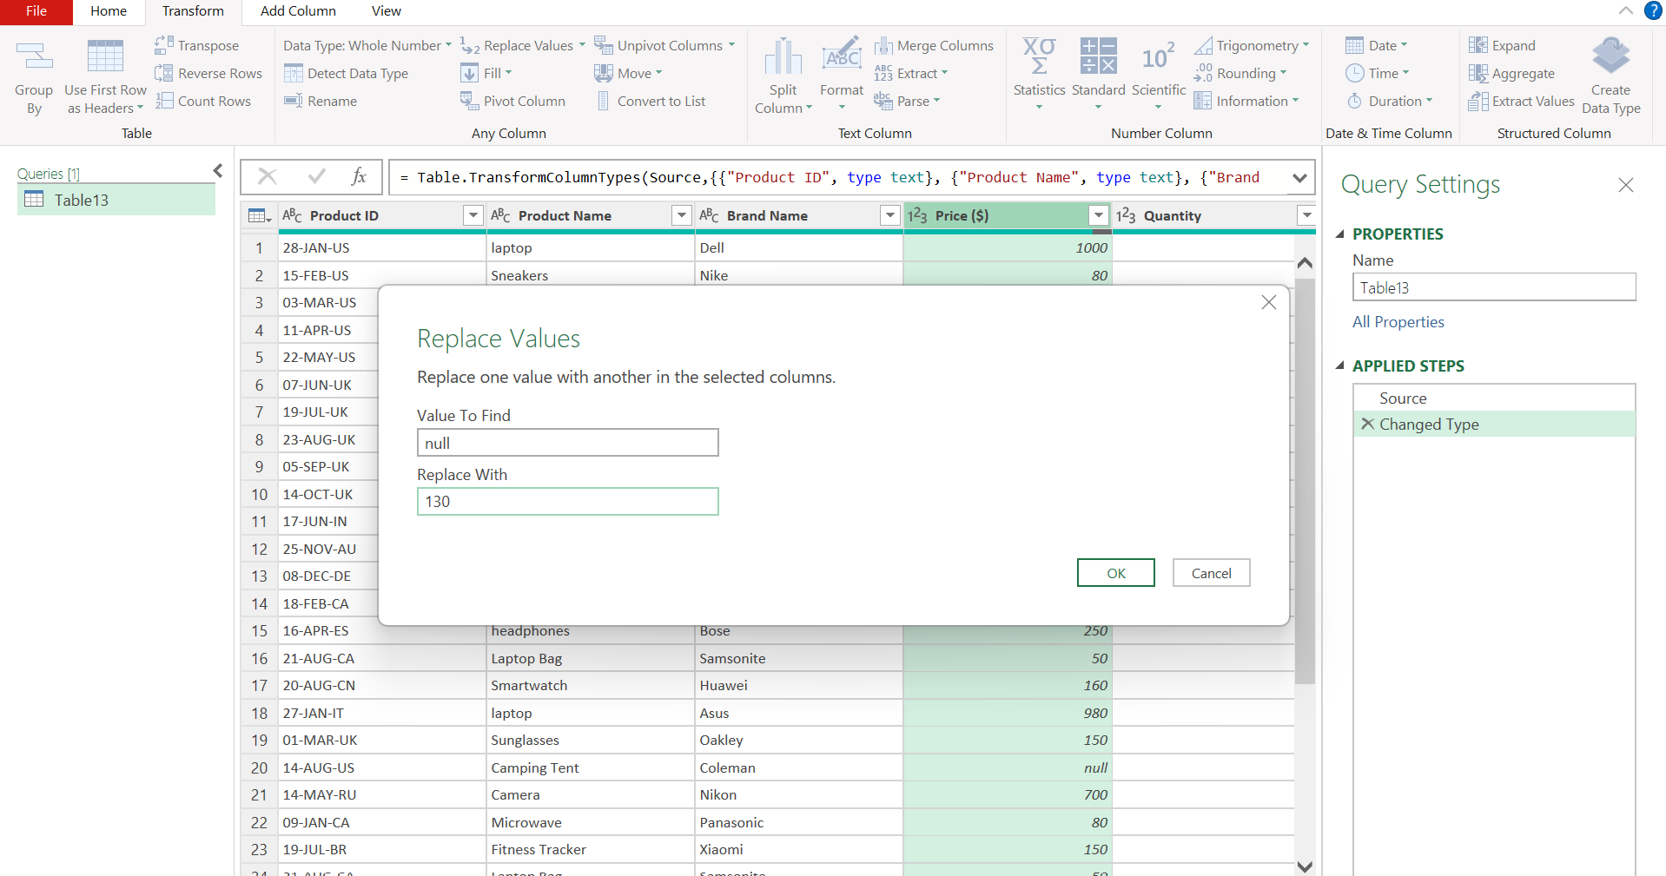

Price value with null is now updated with 130
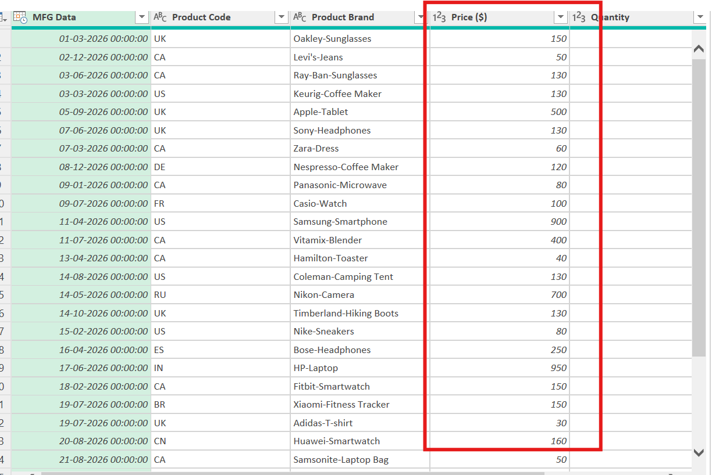

We see missing (null) values in Category column
Added a Conditional Column and named as Product Category
Based on the Product name and its type applied IF conditions to categorized the missing category as below
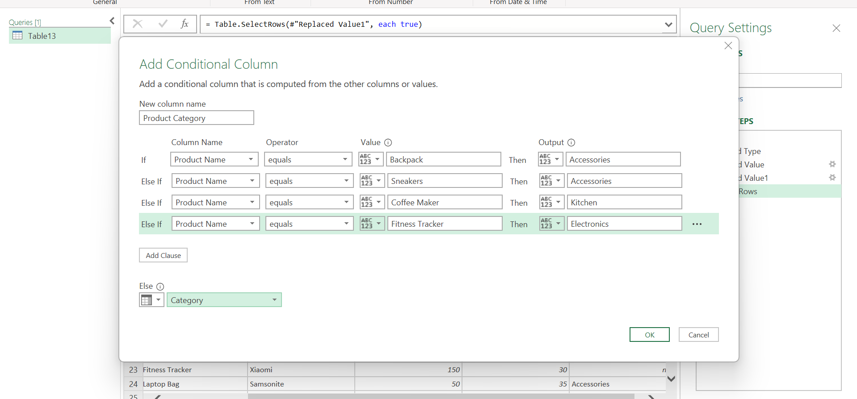

2. Correcting Inconsistent Data:
Found Inconsistent values in the Product Name column as shown below
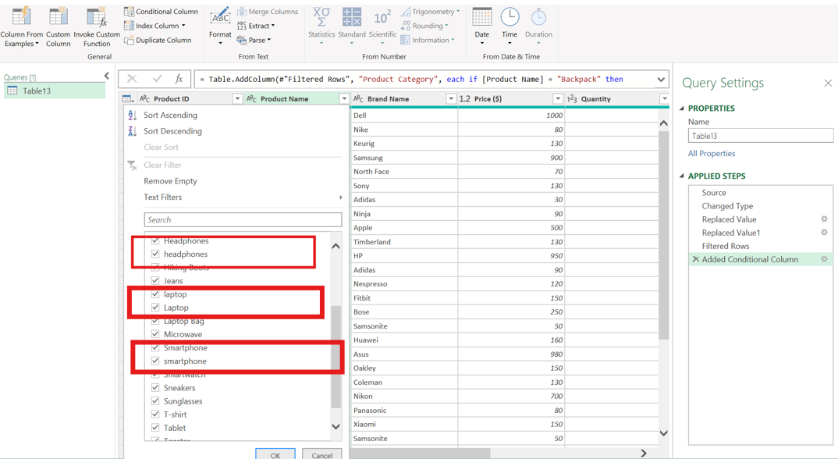

Replaced the repeated inconsistent text to standardized format using find and replace function as shown below
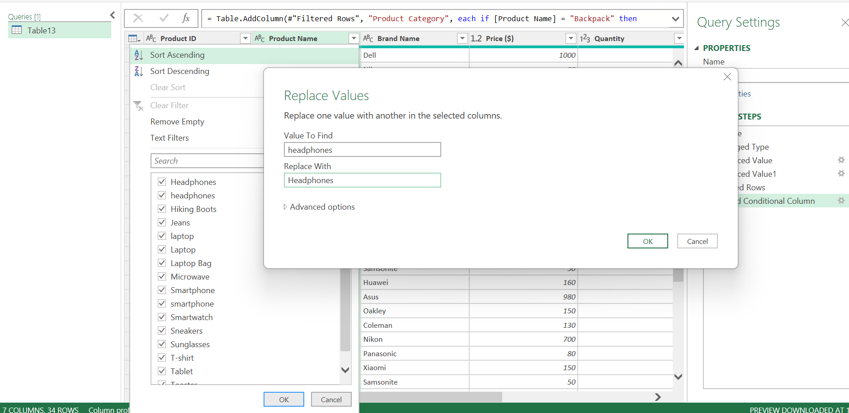
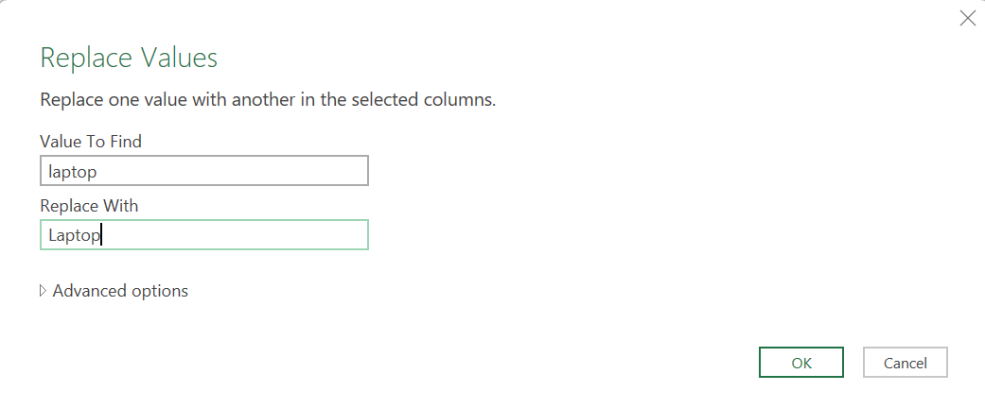

Found typos in the category column (Electroni)
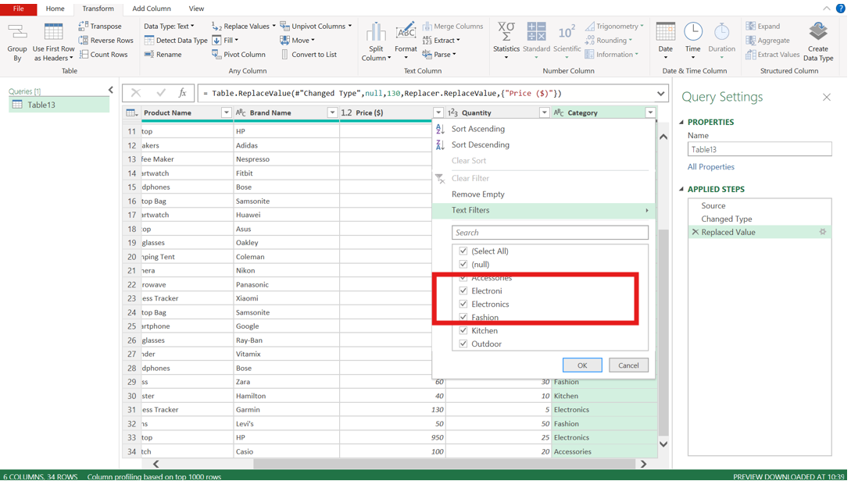
Replaced the “electroni” text with correct format “Electronics”
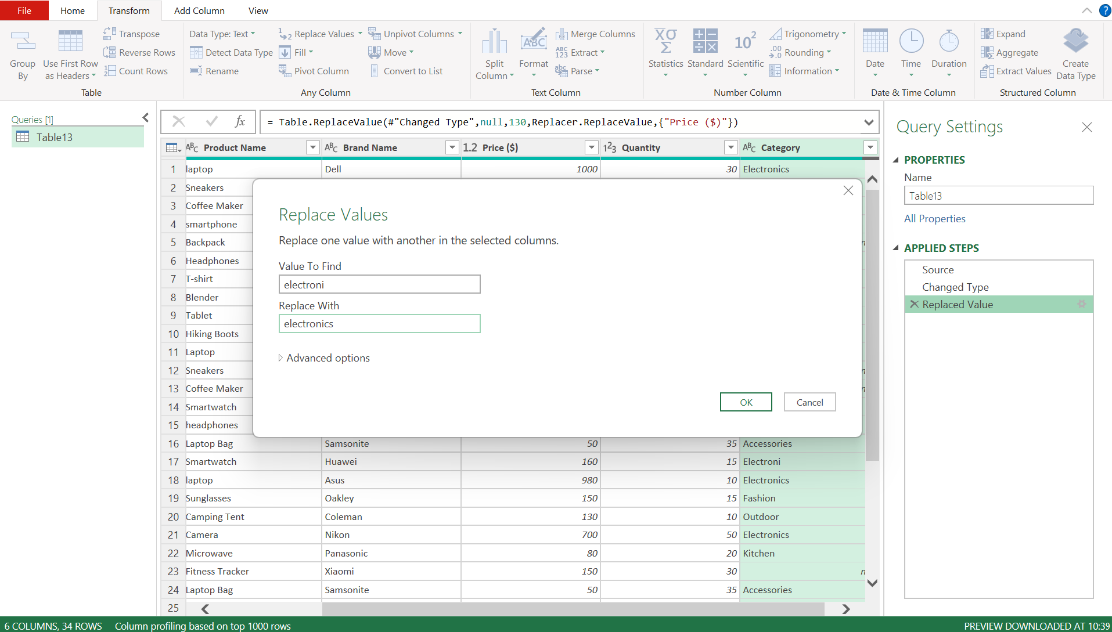

- Removing Duplicates:
Sorted the Product ID column as ascending order to check duplicate entries and found 3 Duplicate entries.
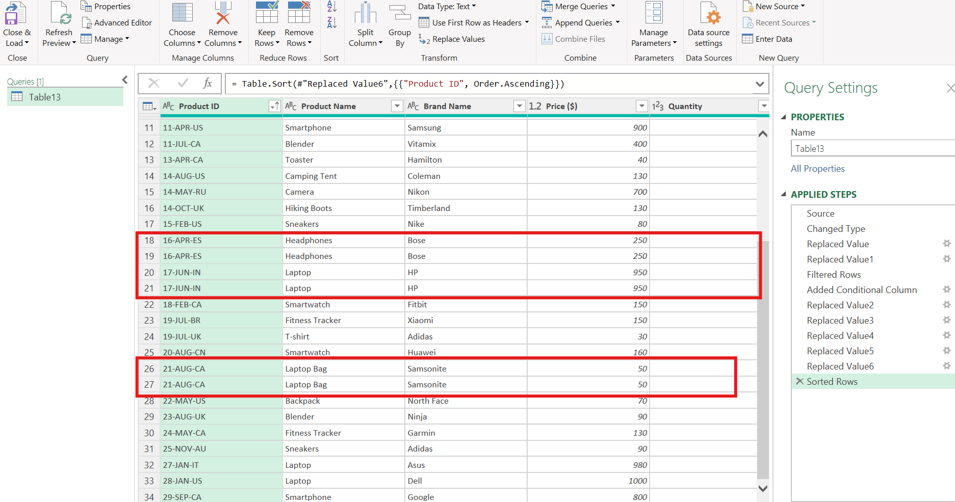

Removed duplicate entries by selecting “Remove Duplicate” option under Home as shown below
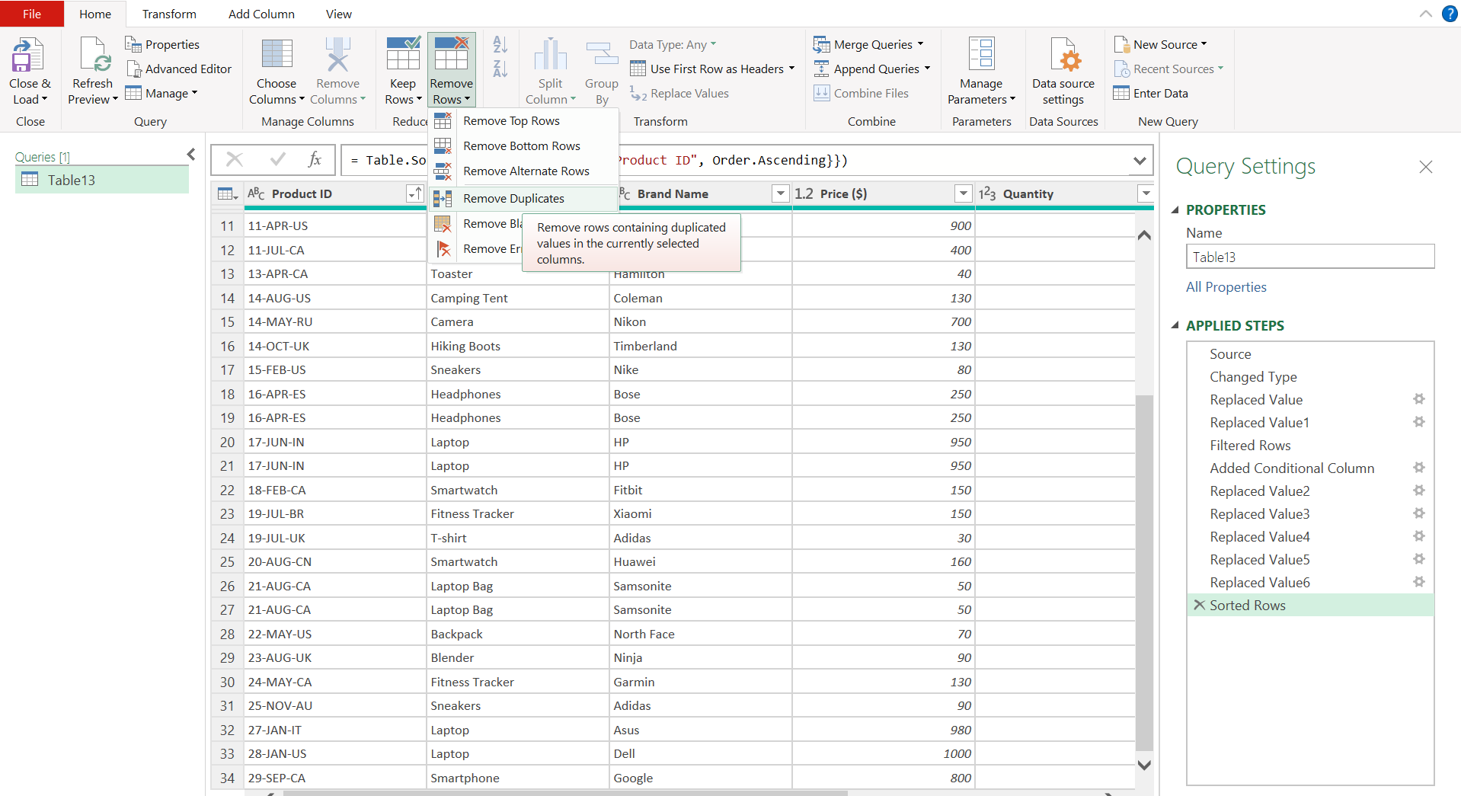

Duplicates are removed
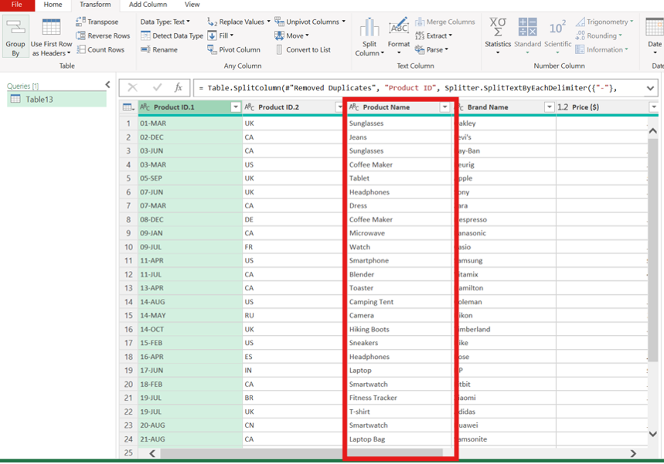

4. Splitting and Merging Data:
By selecting the Split Column option under home tab – Split by Delimiter
For delimiter details custom “-“ right most delimiter OK
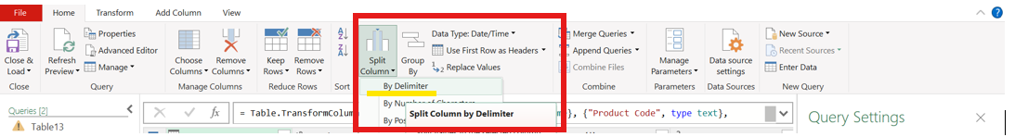
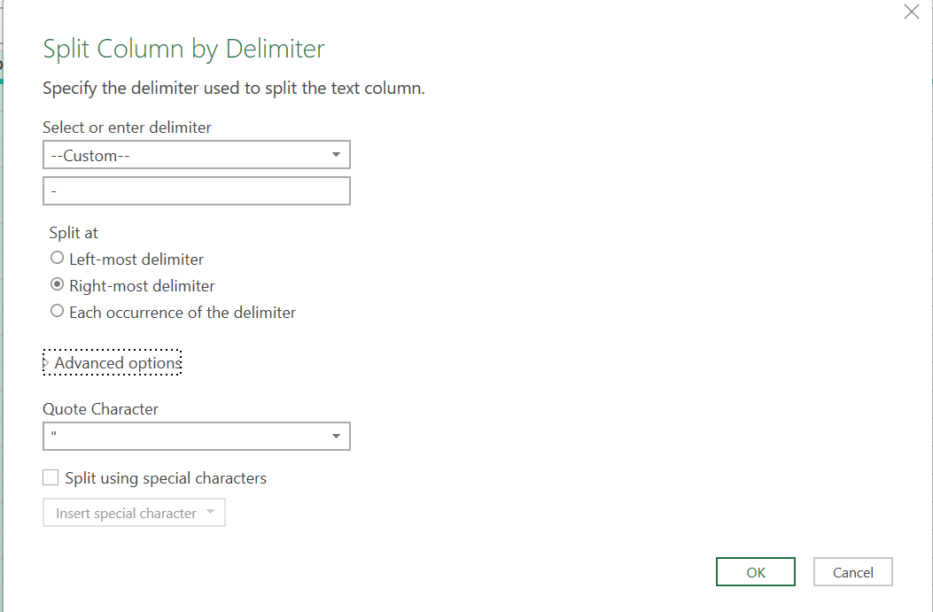
Product ID is now Split into 2 Columns 1st column with Manufacturing date and 2nd column with Product code as per our instruction.
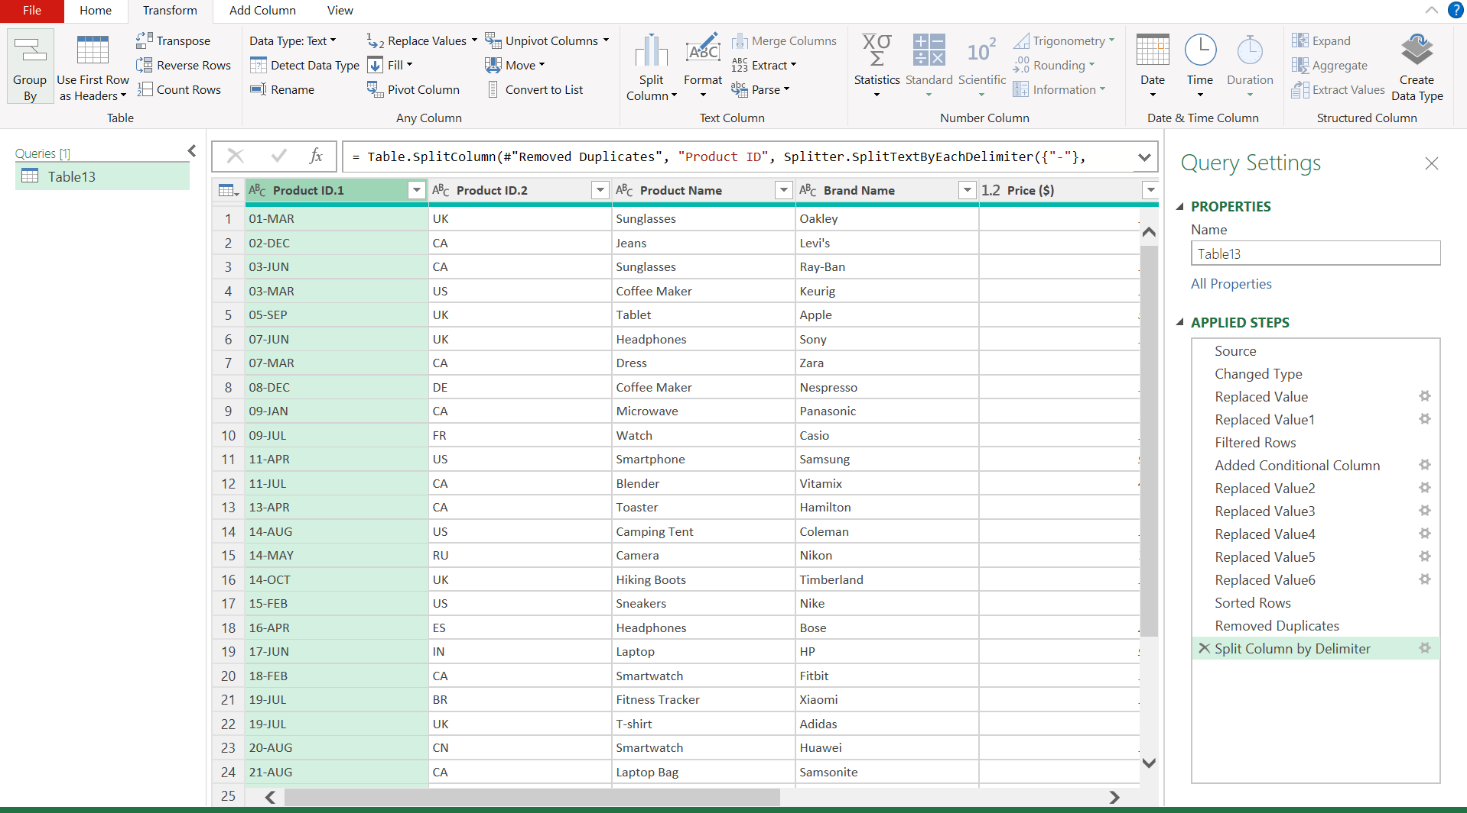

Merged Product Name and Brand Name by selecting them and clicking Merge column under home tab.
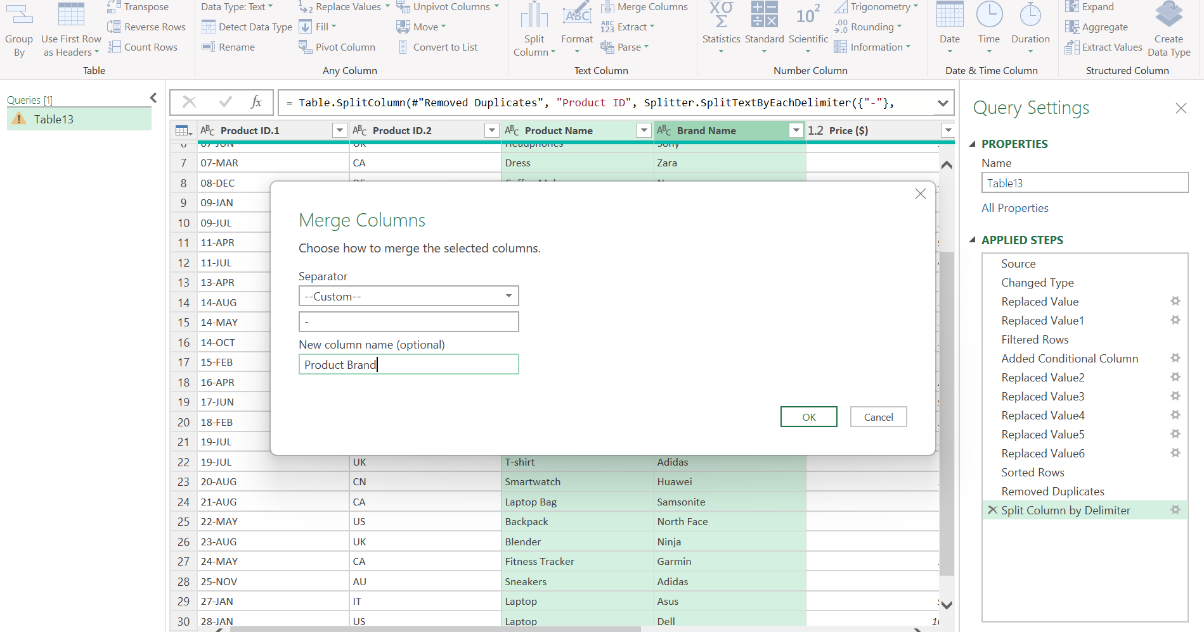
The Product name and Brand Name column is merged and separated by a delimiter “-“ and renamed the column as “Product Brand”
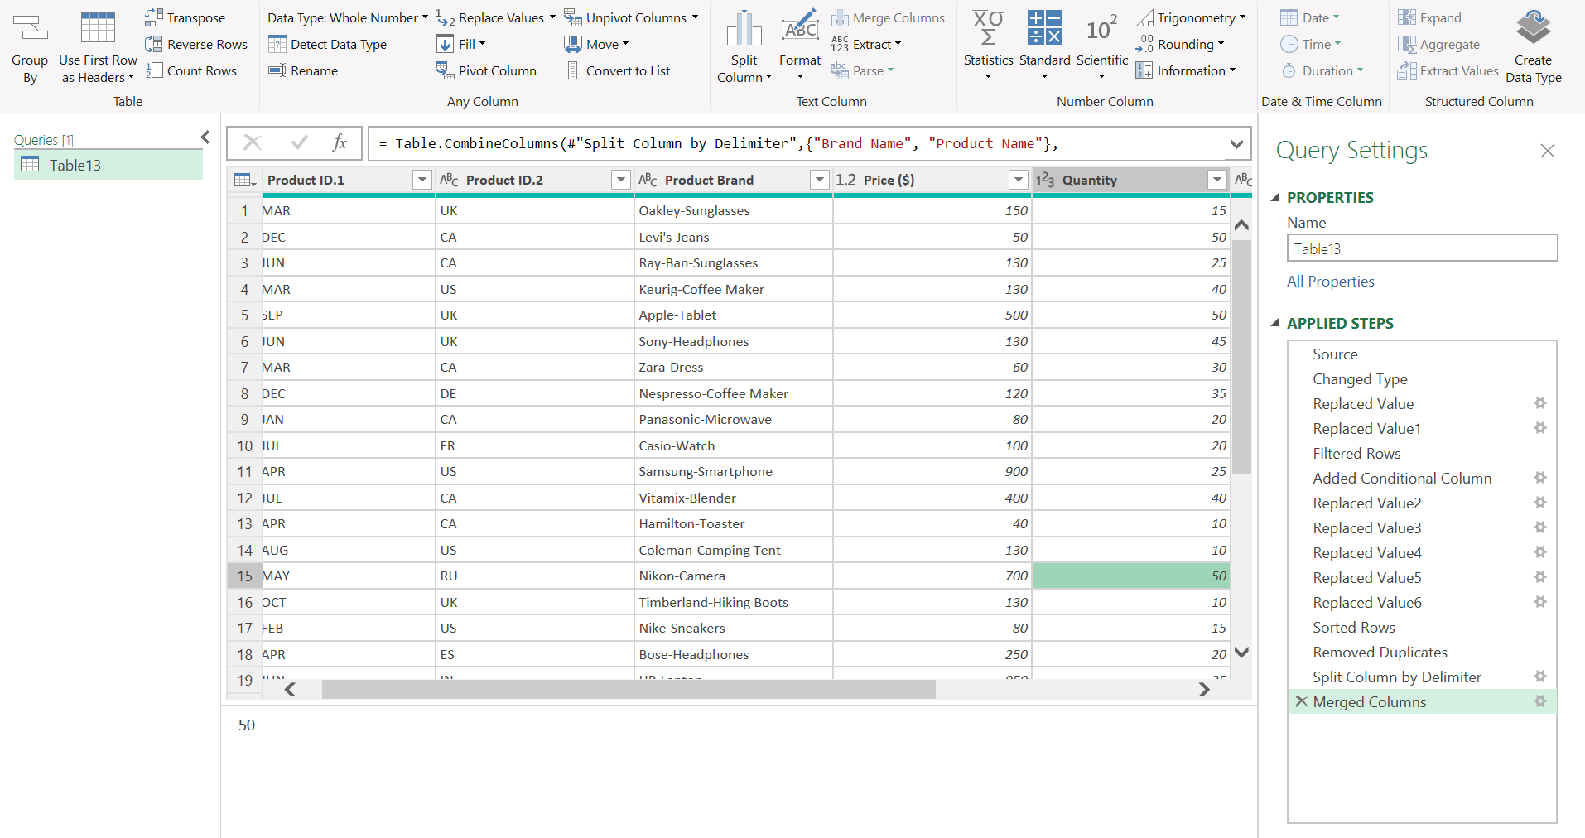

5. Number Formatting:
Formatted the Price column data type as Currency data type
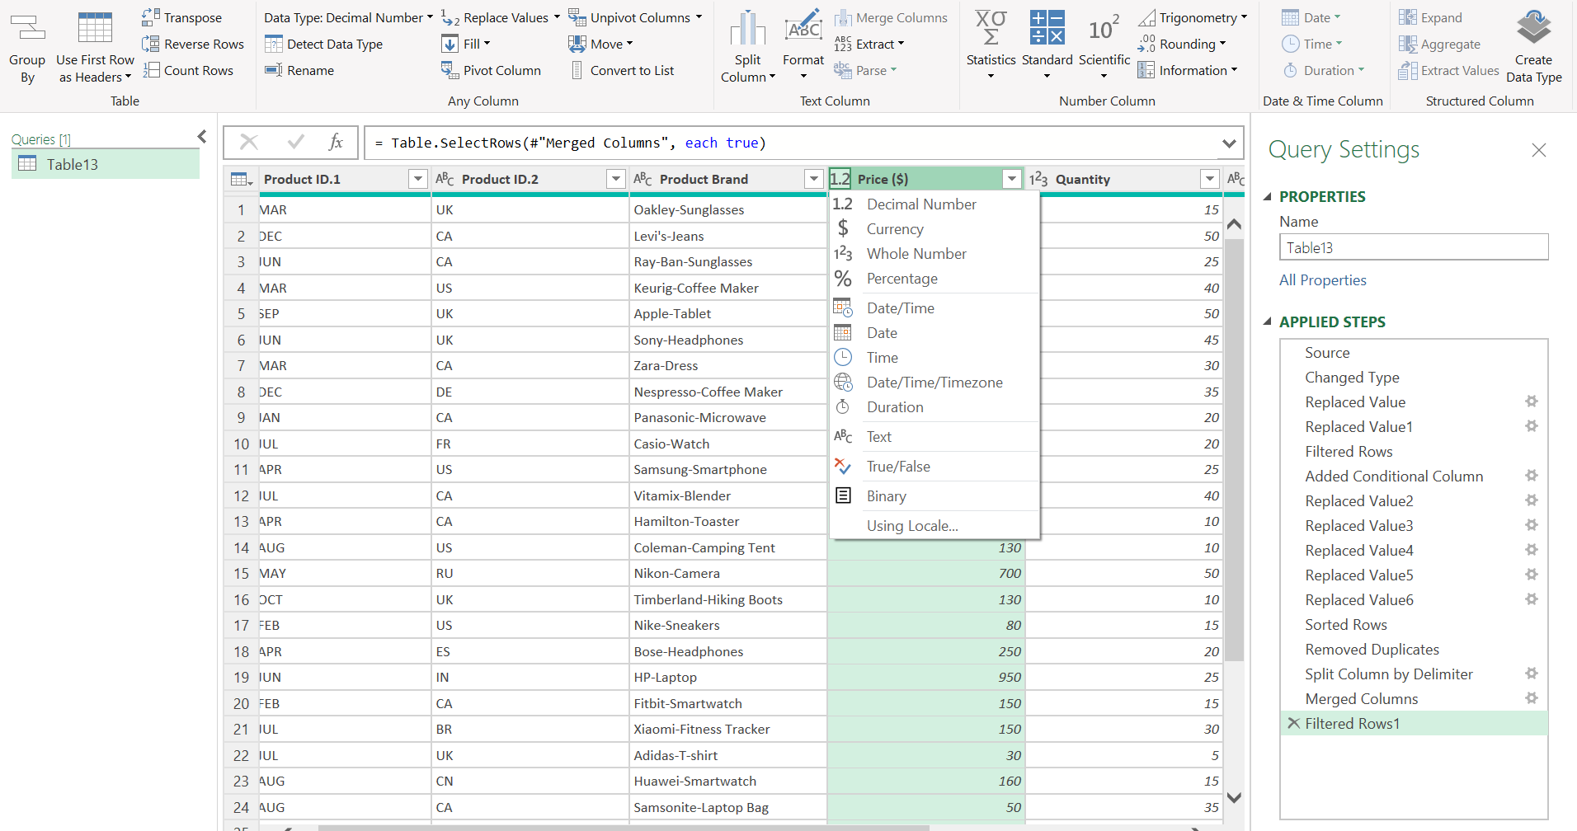

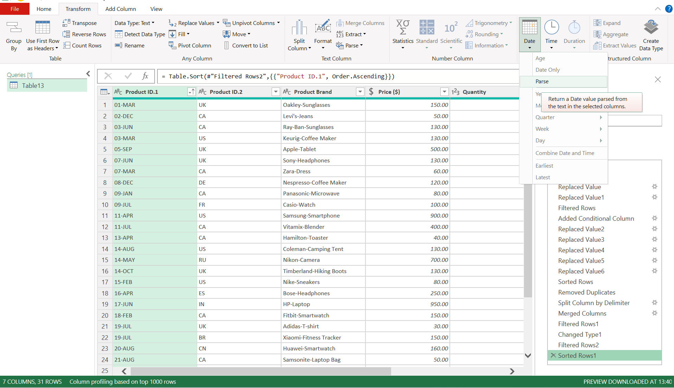
Formatted the "Manufacturing Date" column to display dates in the "DD-MM-YYYY "
format.
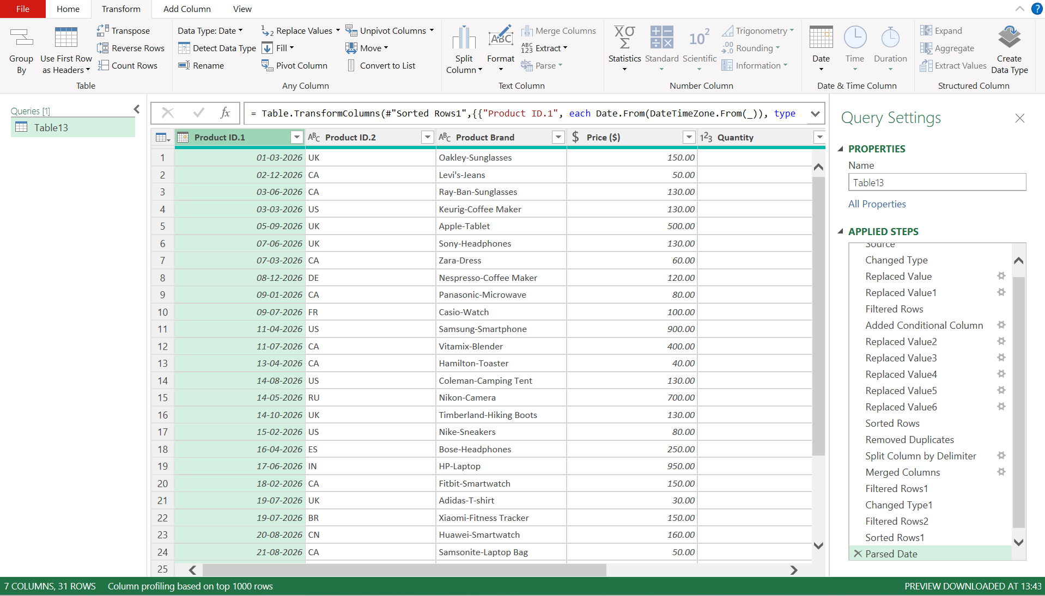

Closed and loaded the Power Query to save and to get back to Excel.

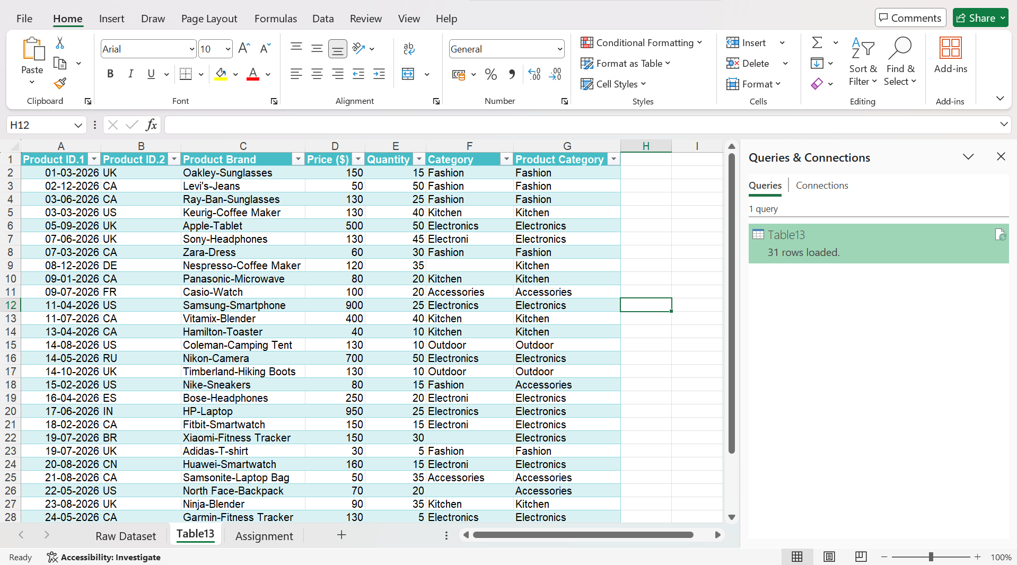

6. Conditional Formatting:
To apply data bar formatting in Price column, selected the price column and selected “Data Bars” under Home Conditional Formatting as shown below.
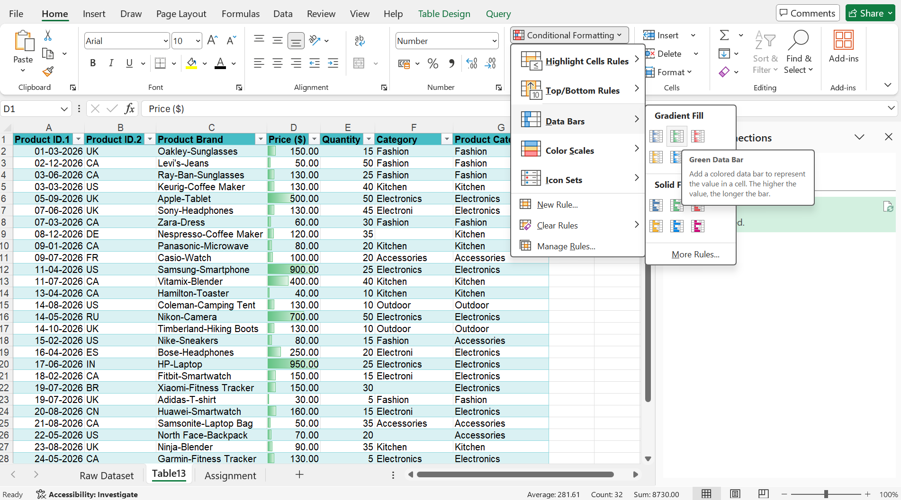

Customized a rule for conditional formatting in the "Product Category" column to highlight cells where the category is "Electronics." By choosing “Text that contains” under “Conditional Formatting” “Highlight Cells Rules”
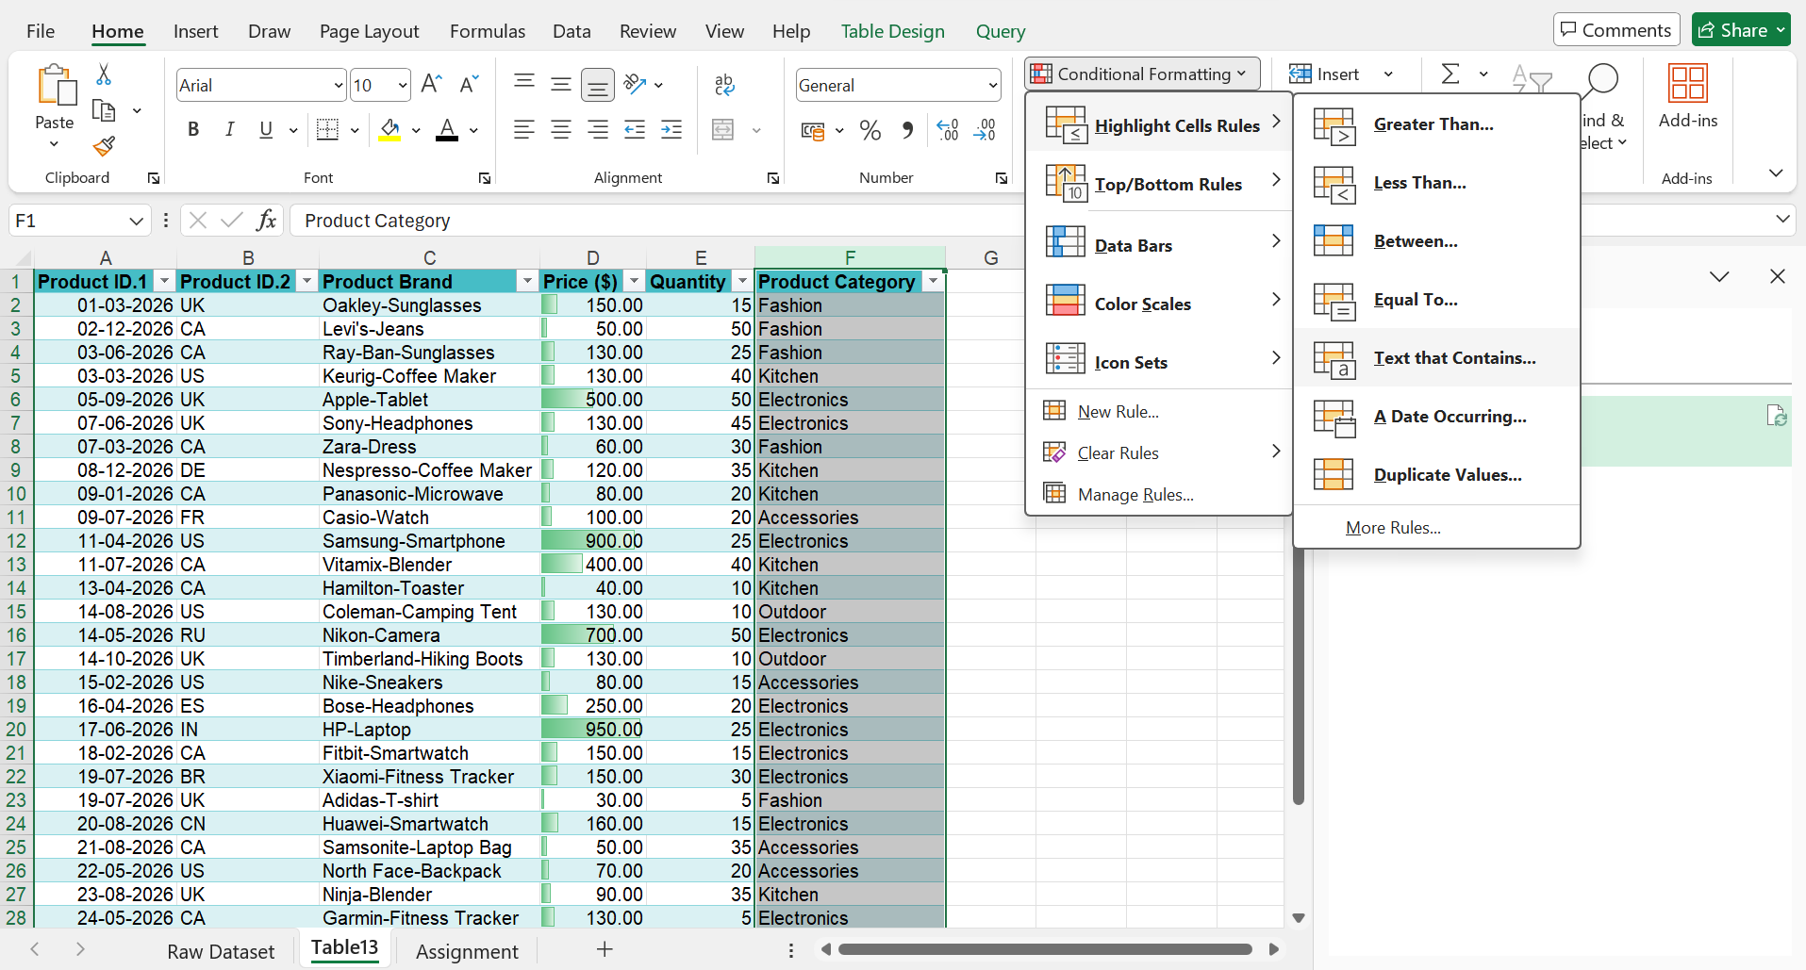

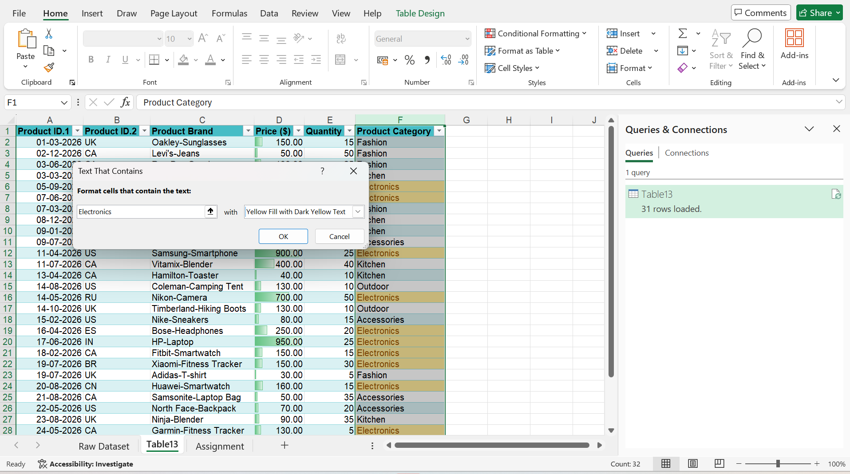

Updated the Column name for Product ID 1 – MFG Date and Product ID 2- Product Code
Final Excel File fulfilling all the instruction
